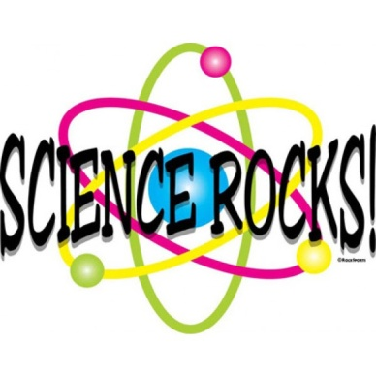

Jordan/Jackson Science Nights with Dr. Bob!

MESA has teamed up again with Dr. Bob Morris, Ph.D of Wheaton College for exciting nights of SCIENCE WITH DR. BOB on Monday, January 16th,Tuesday, January 17th and Wednesday, January 18th at 6:30pm! 3rd, 4th and 5th Graders may come any night, but please only sign up for one night!
See below to sign up.

Dr. Bob is an award-winning teacher and researcher who has been communicating the fun and excitement of science to the young and not-so-young for more than 30 years. Dr. Bob's enthusiastic and entertaining approach to science education has led to classroom and public appearances across the country (including here in his hometown of Mansfield), to hosting "Family Science Nights" in Maine and now also at MMAS Arts Center at Great Woods, and hosting a TV series on Mansfield Cable Access called "Science with Dr. Bob!" For more information on Dr. Bob's credentials, please see his Wheaton faculty profile at https://wheatoncollege.edu/academics/faculty-directory/robert-l-morris/ and his website ScienceWithDrBob.com.

Students must be accompanied by a parent or guardian.
Parental participation is imperative to the success of this event. Parents/guardians must remain with the student and engage in the experiments.
*Please NO SIBLINGS!* (other than J/J students)

Monday Night sign up here:
https://www.signupgenius.com/go/5080d4eafa628a4f49-monday
Tuesday Night sign up here:
https://www.signupgenius.com/go/5080d4eafa628a4f49-tuesday2

Wednesday Night sign up here:
https://www.signupgenius.com/go/5080d4eafa628a4f49-wednesday

